

Digitizing Guidelines

Objective:
This handout will detail the steps you need to complete in order to properly digitize/scan items.

Before you begin:
- Convert today’s date into one consecutive number (e.g. August 1, 2013 = 080113)
- Locate your cataloging spreadsheet.
- You’ll need your group hard drive to save files to. Create a folder with your archive name to store all the files. For example: Cotera_Archive. Within this folder make a Scans folder and a Video folder.
- You’ll need at least 10gbs free space on your designated data wrangler’s M+Box Account. See Step 3 for more information on M+Box.

Steps:
Step 1. Sorting
  - Carefully sort items into documents and photographs
  - Sort photographs into (a) 8’’ x 10’’ or larger, (b) 5’’ x 7’’, and (c) 4’’ x 5’’ or smaller
  - Set aside tricky or hard to scan pieces for later.
Step 2. Scanning
2.1 Open EPSON Scan software, it may be stored in your applications folder.
2.2 Determine the correct PPI resolution based on your image size. You’ll need to input this in the scanning window described in step 2.2.
Item | Size | Minimum Resolution in PPI
Documents
 | Any size | 300
Photographs
 | 8’’ x 10’’ or larger | 400
 | 5’’ x 7’’ | 570
 | 4’’ x 5’’ or smaller | 800

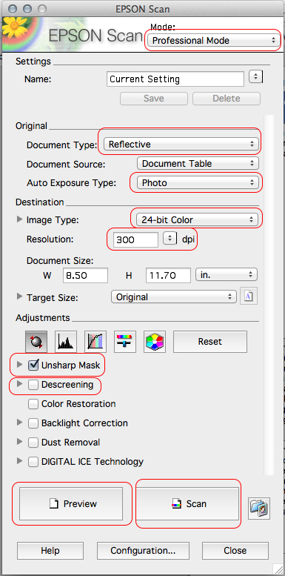
2.3 Configure your scan window to look like the one shown below. Fields outlined below are those that you will need to change/double check.

Set to PROFESSIONAL
MODE

Set as shown, except for negatives

Set for either photo or documents.

Set as shown

Adjust resolution based on the scanning chart.

Unsharp mask should be checked.
Use Descreening if scans are reproducing patterns in images.

2.3 Click Preview. Size the crop to the edge of item, leaving a small amount of space around the archival object. Remember that it is easy to crop later, but impossible to recover anything not scanned. Click Scan.

2.4 Name the item using the accession number naming convention described below.

Please note that you set the Item# in the scanner file save window tick box NOT in the prefix section (see image below)

ArchiveIDNumber_ScanDate_Item#
Example: 100ABC_080113_001

For items that will only be one catalog record, but will have multiple images – a multipage brochure, pamphlet or book - add a single letter to the number described above. You’ll need to do this manually by right clicking and renaming files after scanning.

Example:
100ABC_080113_001_a
100ABC_080113_001_b

2.5 Make sure to save the scan as a TIFF. Save in a folder named LastName_Archive. For instance Luvenos_Archive or Garcia_Archive.

Your file save dialogue box should look like the one below:

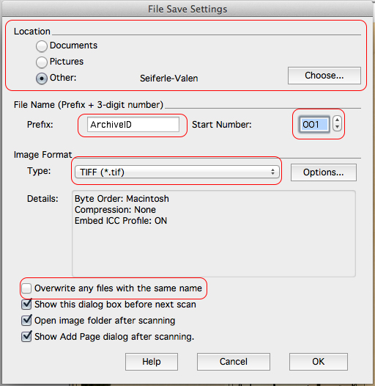

2.6 While the item scans, fill out known information in your cataloging spreadsheet. It may be too time consuming to fill out every field on-site. Feel free to capture notes in the notes section of your spreadsheet that you can use to fill out the other fields later.

Step 3. Back-up Uploading:

3.1 Within 24 hours of your interview date, your designated data wrangler is responsible for uploading your scanned and video files to their M+Box Account.

Configure your options under Share/Access until they look like the image below:

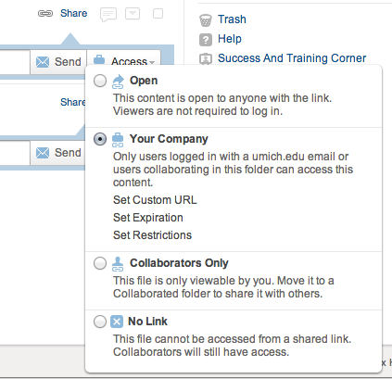

Then share with mariasv@umich.edu. Please also send an additional email from your personal account to Maria S-V when this has been completed and she will email you a confirmation.

Please note: All students have 50gb of could storage available through M+Box.
You can access M+Box here: https://box.it.umich.edu/
Get M+Box help here: http://www.itcs.umich.edu/storage/box/faq.php#general

